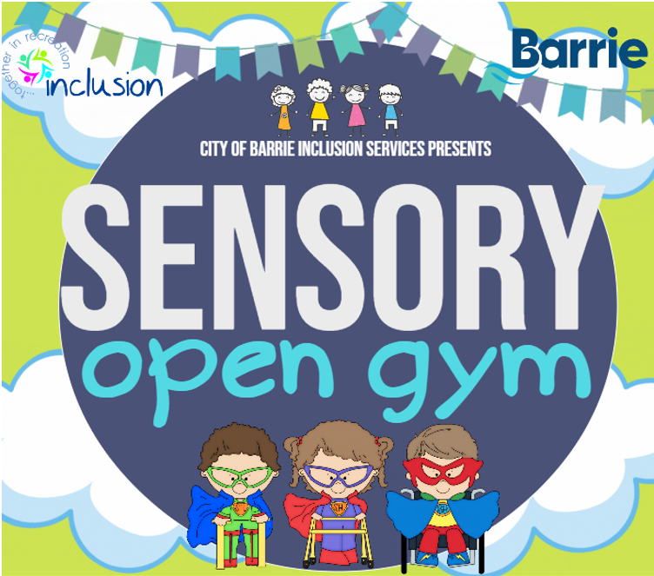

SENSORY AWARE GYMNASIUM DROP-IN SPACE THAT GIVES INDIVIDUALS WITH DISABILITIES THE OPPORTUNITY TO PLAY AND TRY OUT GYMNASTICS IN A SAFE AND FUN ENVIRONMENT.

**ALL PARTICPANTS MUST ATTEND WITH THEIR OWN SUPPORT.**

**ONE SUPPORT PERSON PER INDIVIDUAL ATTENDING.**

LAMPMAN LANE COMMUNITY CENTRE

$2.00 (cash only) per participant, support workers enter for free

59 LAMPMAN LANE, BARRIE, ON L4N 5G4

**TUESDAYS 5:15-6:30 p.m. FUNNASTICS PRESCHOOL // TUESDAYS 6:30-8:15p.m. FUNNASTICS**

FUNNASTICS